Test Case: tc001_SPX_Dev5_Crear_Solicitud_Articulo_Almacen
Step 1 - Enter username and password and click to button Enter : Credentials Entered
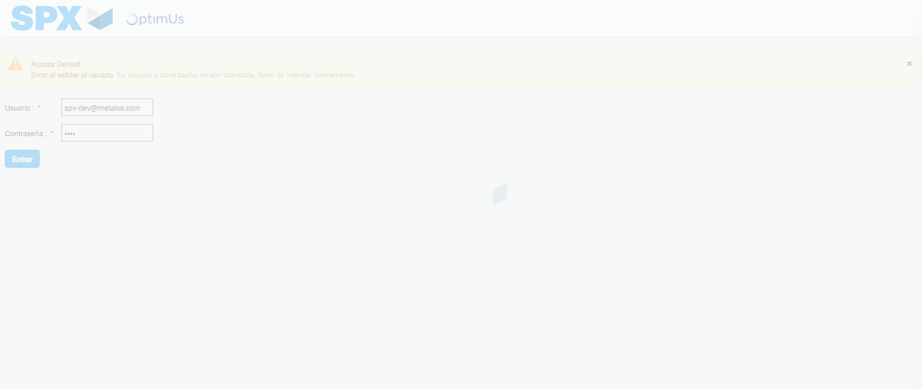Image file-name: QC_Testing-tc001_SPX_Dev5_Crear_Solicitud_Articulo_Almacen-1787932636603

Step 2 - Select to UEN and Access to Request for a New Inventory Item : UEN Correctly selected and Correct access
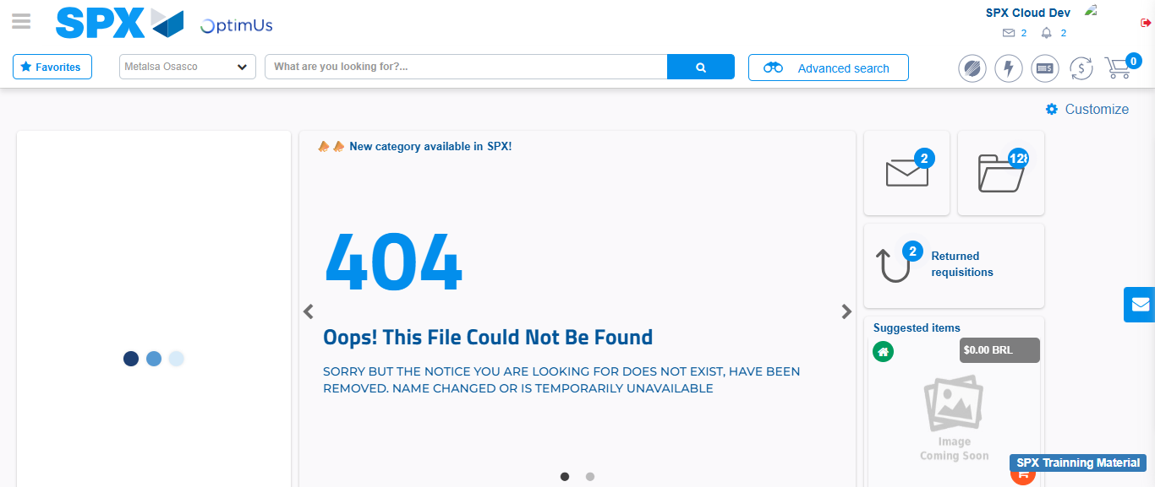Image file-name: QC_Testing-tc001_SPX_Dev5_Crear_Solicitud_Articulo_Almacen-1787932662739

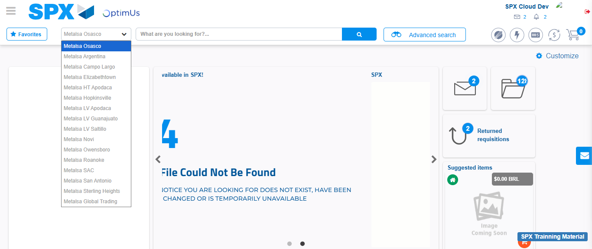Image file-name: QC_Testing-tc001_SPX_Dev5_Crear_Solicitud_Articulo_Almacen-1787932663376

Image file-name: QC_Testing-tc001_SPX_Dev5_Crear_Solicitud_Articulo_Almacen-1787932683944

Step 3 - Select options first section : Options seleted correctly
Image file-name: QC_Testing-tc001_SPX_Dev5_Crear_Solicitud_Articulo_Almacen-1787932684209

Image file-name: QC_Testing-tc001_SPX_Dev5_Crear_Solicitud_Articulo_Almacen-1787932684397

Step 4 - Select options at Screen: Options seleted correctly
Image file-name: QC_Testing-tc001_SPX_Dev5_Crear_Solicitud_Articulo_Almacen-1787932684209

Image file-name: QC_Testing-tc001_SPX_Dev5_Crear_Solicitud_Articulo_Almacen-1787932684397

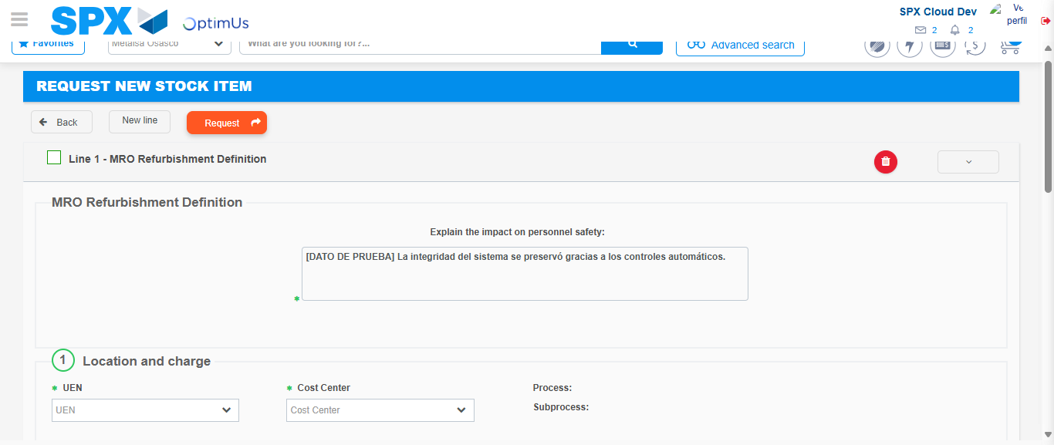Image file-name: QC_Testing-tc001_SPX_Dev5_Crear_Solicitud_Articulo_Almacen-1787932690664

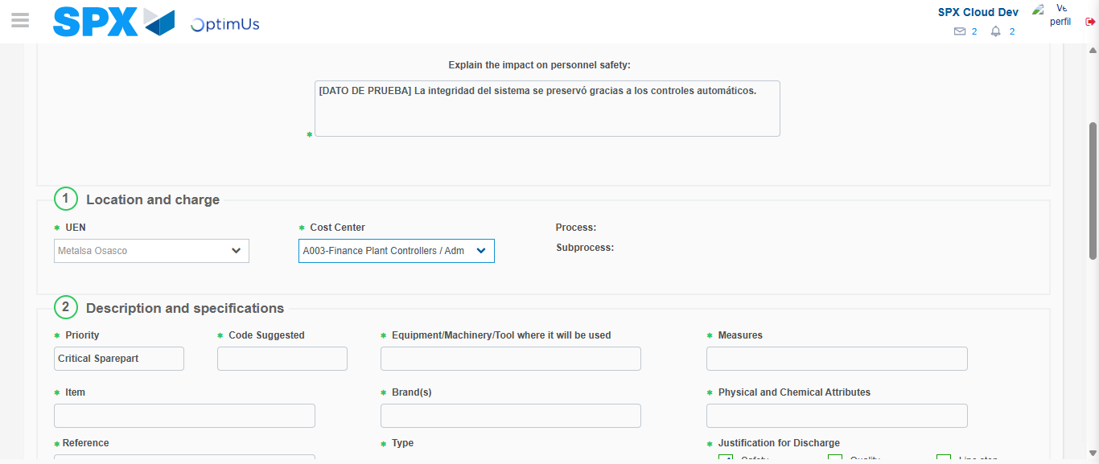Image file-name: QC_Testing-tc001_SPX_Dev5_Crear_Solicitud_Articulo_Almacen-1787932693581

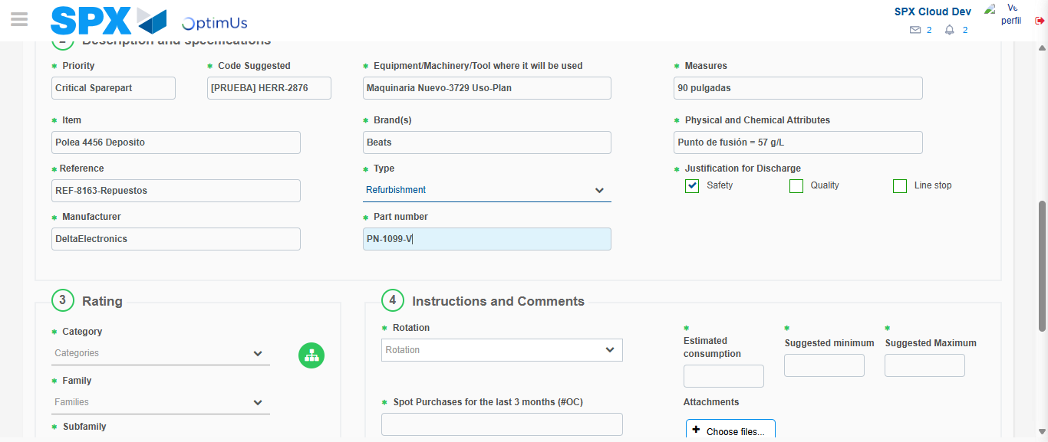Image file-name: QC_Testing-tc001_SPX_Dev5_Crear_Solicitud_Articulo_Almacen-1787932695413

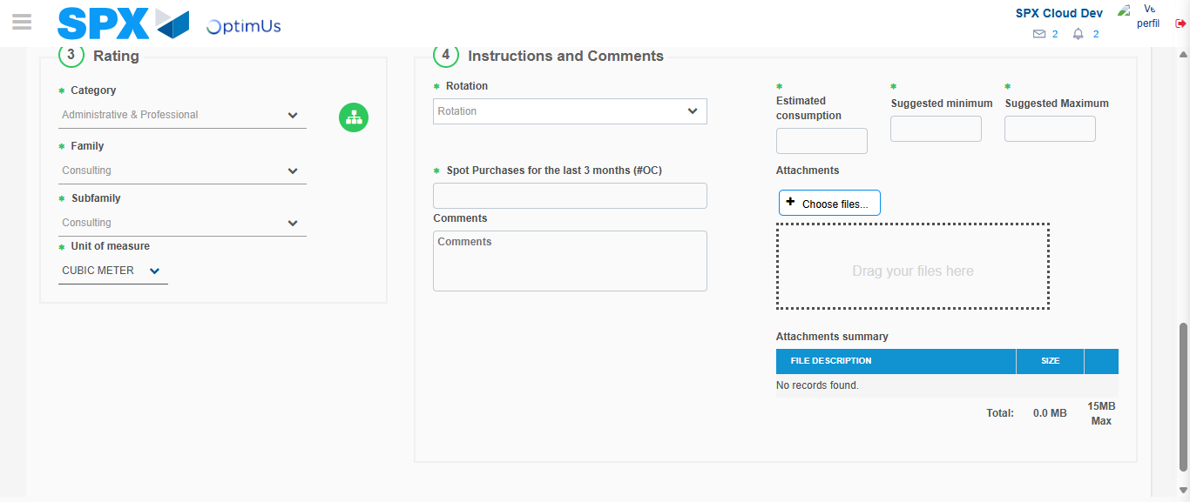Image file-name: QC_Testing-tc001_SPX_Dev5_Crear_Solicitud_Articulo_Almacen-1787932700177

Step 5 - Request New Item : Request Accepted
Image file-name: QC_Testing-tc001_SPX_Dev5_Crear_Solicitud_Articulo_Almacen-1787932662739

Image file-name: QC_Testing-tc001_SPX_Dev5_Crear_Solicitud_Articulo_Almacen-1787932663376

Image file-name: QC_Testing-tc001_SPX_Dev5_Crear_Solicitud_Articulo_Almacen-1787932683944

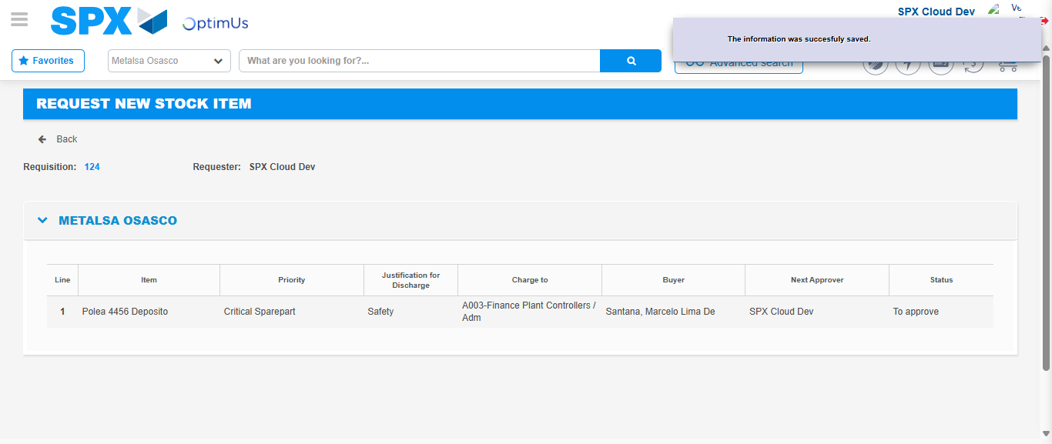Image file-name: QC_Testing-tc001_SPX_Dev5_Crear_Solicitud_Articulo_Almacen-1787932707129

Image file-name: QC_Testing-tc001_SPX_Dev5_Crear_Solicitud_Articulo_Almacen-1787932707316

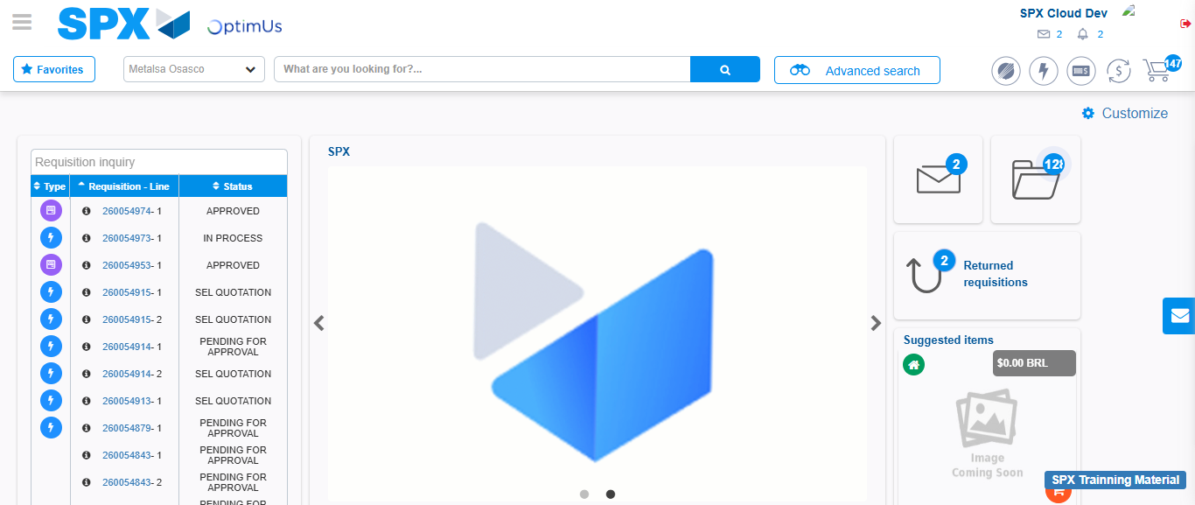Image file-name: QC_Testing-tc001_SPX_Dev5_Crear_Solicitud_Articulo_Almacen-1787932728537

Step 7 - Return to Main Page SPX : Return to Main Page SPX
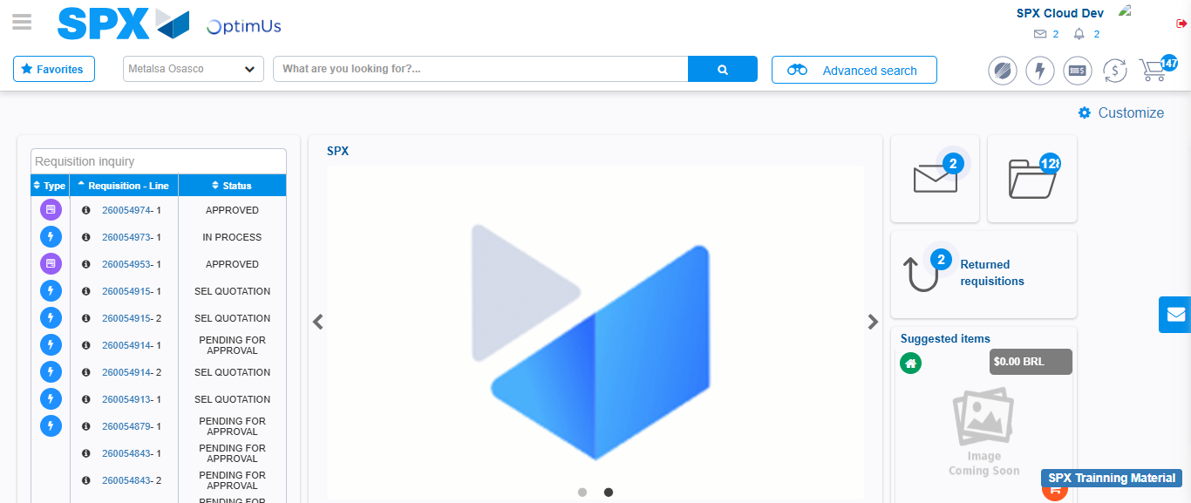Image file-name: QC_Testing-tc001_SPX_Dev5_Crear_Solicitud_Articulo_Almacen-1787932728886

